CB&B752/MCDB452/MB&B752/MCDB752/CPSC752
April 26, 2107

1. Name two of the seven residues with positive hydrophobicity values on the Kyte-Dolittle hydrophobicity scale.

2. What is the densest packing fraction for monodisperse hard spheres? What is the densest packing fraction for disordered collections of monodisperse hard spheres? What is the packing fraction of all-atom hard-sphere (i.e. explicit hydrogen) representations of residues in protein cores?

3. Plot the purely repulsive Lennard-Jones interatomic potential (V/ε versus r_{ij}/σ_{ij}) given by
for r_{ij} ≥ σ_{ij} and V(r_{ij}) = 0 for r_{ij} < σ_{ij}, where r_{ij} is the center-to-center separation between atoms, σ_{ij} = (σ_{i}+σ_{j})/2 is the average diameter of spherical atoms i and j, and the strength of the potential ε is a constant.

4. Calculate the x-, y-, and z-components of the force on atom i from neighboring atom j, ${\vec{F}}_{ij}=-\frac{dV}{dr_{ij}}{\hat{r}}_{ij}$ from the purely repulsive Lennard-Jones potential in question #3.

5. Below, a Ramachandran plot based on the original theoretical calculations is shown. Label the regions of the plot that correspond to α-helix and β-sheet backbone conformations and describe roughly what is the difference between the yellow and red regions of the plot.

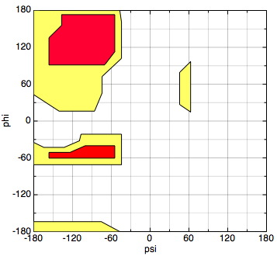

6. What is a Voronoi Tessellation?

7. How does the radius of gyration R_{g} ~ N^{ν} grow the number of residues N for a protein that behaves as a a) collapsed polymer, b) random walk, and c) self-avoiding random walk?

